

|  |
| --- |
| Version 1.1  **Last saved by: Ben McGregor**  **Last saved on:** 29/03/2015 |

|  |
| --- |
| Reasons for developing with Android |
| 25/09/2014 |
| **Charlotte Hutchinson**  CO600: JustHealth Supervisor: Yang He |

Contents

1.0 Introduction 2

2.0 Platforms 2

2.1 IOS 2

2.2 Windows 2

2.3 Android 2

3.0 Conclusion 3

4.0 References 4

# Introduction

This document will look into the platform options we have for developing our app and discuss the positives and negatives for each one.

For developing our app we have 3 main platforms to chose from:

* IOS
* Android
* Windows

# Platforms

## IOS

The biggest positive for developing in IOS is for financial reasons. iOS apps can make the most money. According to the business insider study ‘Android developers are only making $0.19 for every $1.00 that iOS developers make’. However, because we are not making this for financial reasons this is irrelevant to us.

When researching android we found that IOS would have to be developed in either object C or swift. We felt with that with the small time we have to develop this app we would not be able to learn object C to the standard we would like. With Swift you have to have a license to be able to develop an app therefore we thought this was not practical. Another disadvantage of iOS is that it is a closed platform.

## Windows

The advantages to develop an app in windows is that fewer companies develop in windows therefore there is a opportunity to develop apps that are already successful on IOS and android.

The disadvantages of developing a Windows app are that windows only have a very small market share and not widely used.

## Android

To build and android app we can build it in Java which we already know and have a good knowledge of. Also when researching the popularity of all 3 platforms, Android was by far the most popular.

<http://www.bbc.co.uk/news/technology-29128083>

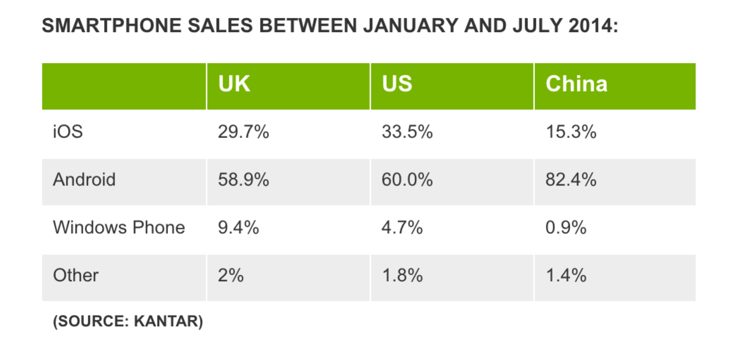

Also according to IDC- Analyze the future

<http://www.idc.com/prodserv/smartphone-os-market-share.jsp>

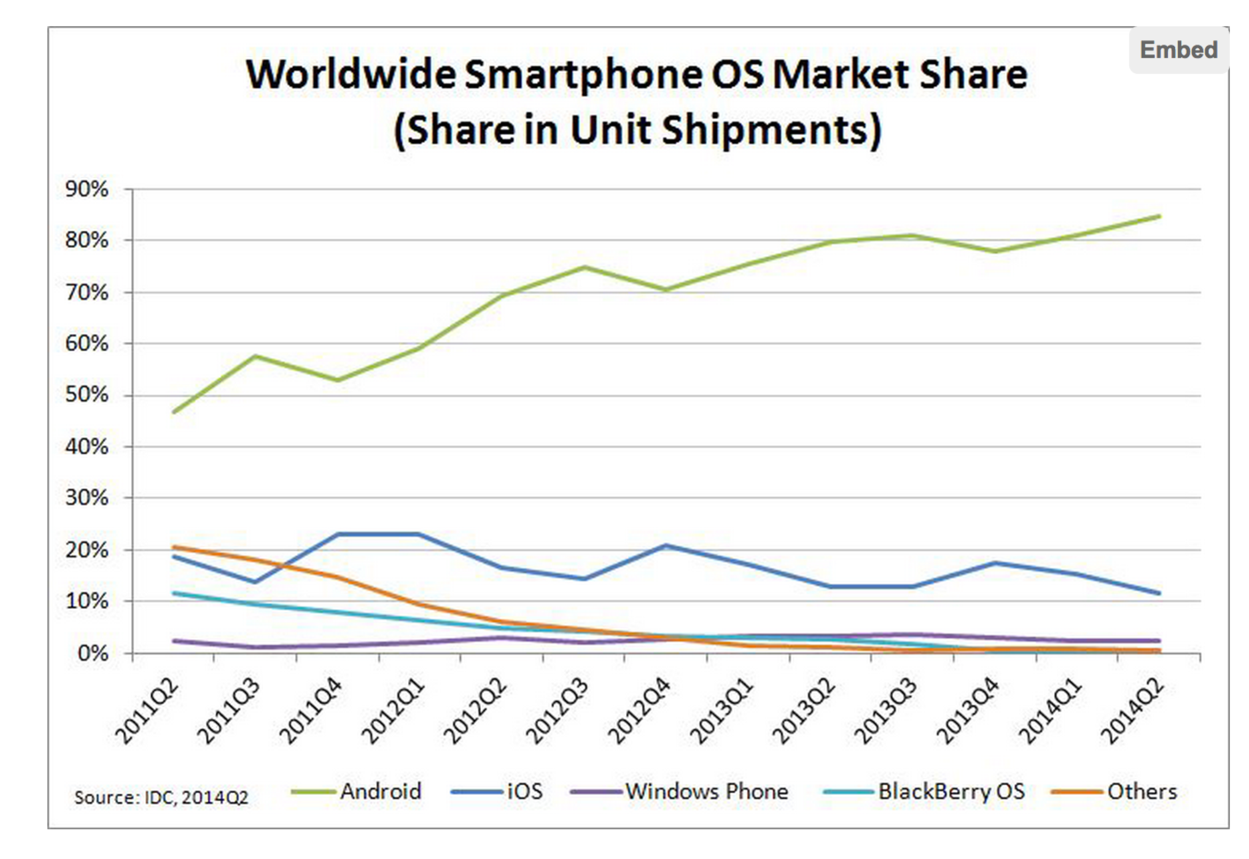

# 3.0 Conclusion

We have decided to develop our app in android for numerous reasons. The 3 options we had for developing were Windows, Apple IOS and Android. We decided against Windows because it is less popular and all 4 of us were not keen on developing in this especially when no one has a Windows phone.

The reason we went against Apple IOS was because it was involve buying a developers license and learning a new language, which we thought would not be possible in the short time available. Therefore android was the obvious answer considering we all have previous Java experience and that it is open source.

# 4.0 References

Sensor Tower (2014) *How to Choose the Best Mobile App Development Platform* [Online] Available at:<http://blog.sensortower.com/blog/2014/02/26/how-to-choose-the-best-mobile-app-development-platform/>

(Last accessed: 24 September 2014)